Assignment 6 – ECE4560
Brett Erickson
- 5 hours
- Completed the survey.
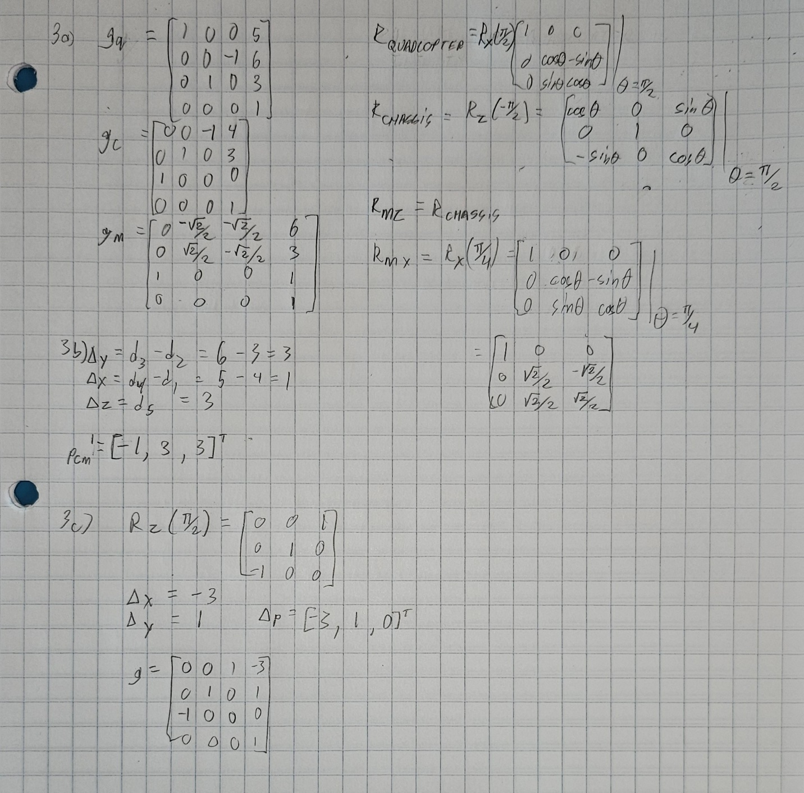
4.
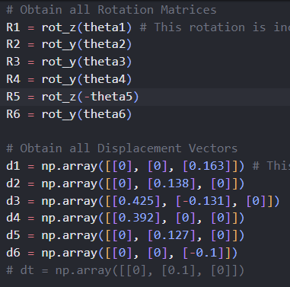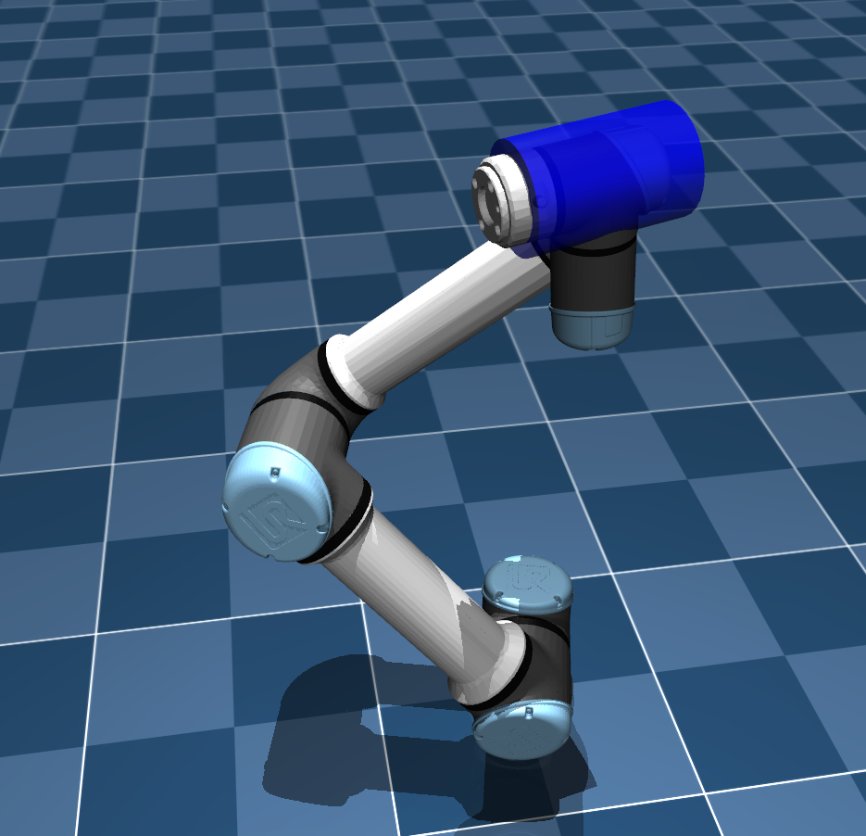

5. Rodrigo went to perform the checkoff for our group.
Finishing the robotic arm code was relatively straightforward, all we had to do was write the get_xx() functions to gain the transformation matrices based on the robot definition of each frame for each DOF.

